After having the Linear and Multinomial Logistic results, we continue to analyze deeper in each Market following: Japan (N225), Europe (N100), China (000001.SS), India (BSEN and NSEI).

Here are the results for each Market:

1. **Japan (N225)**

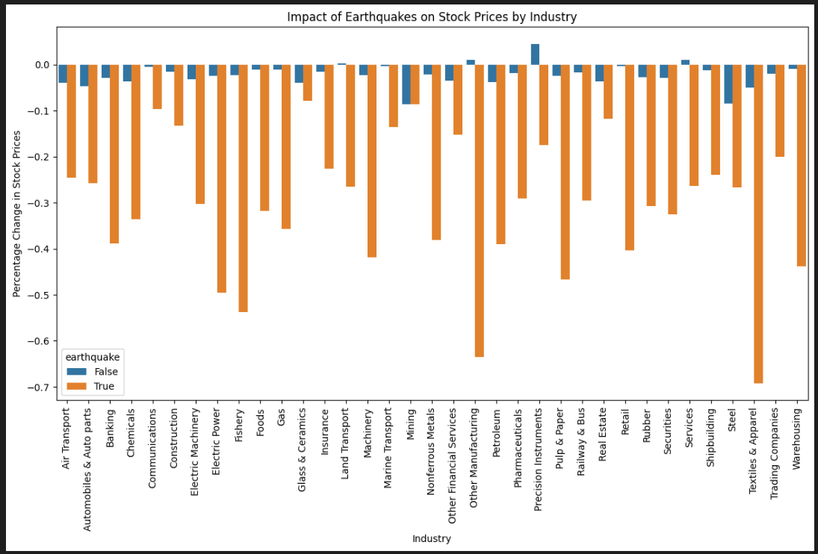

**Explain chart:**

False (average days that there is NO Earthquake), True (average days that there is Earthquake)

The height of each bar represents the average percentage price change

- Negative Impact: If the 'earthquake=True' bar is lower (or negative), earthquakes may correlate with stock declines .

- Positive Impact: If the 'earthquake=True' bar is higher, industries might benefit

- No Impact: Bars of similar height suggest earthquakes have no measurable effect.

**=> In here, all industries have Negative Impact (True > False)**

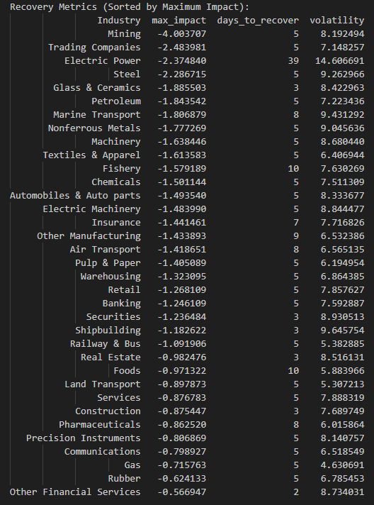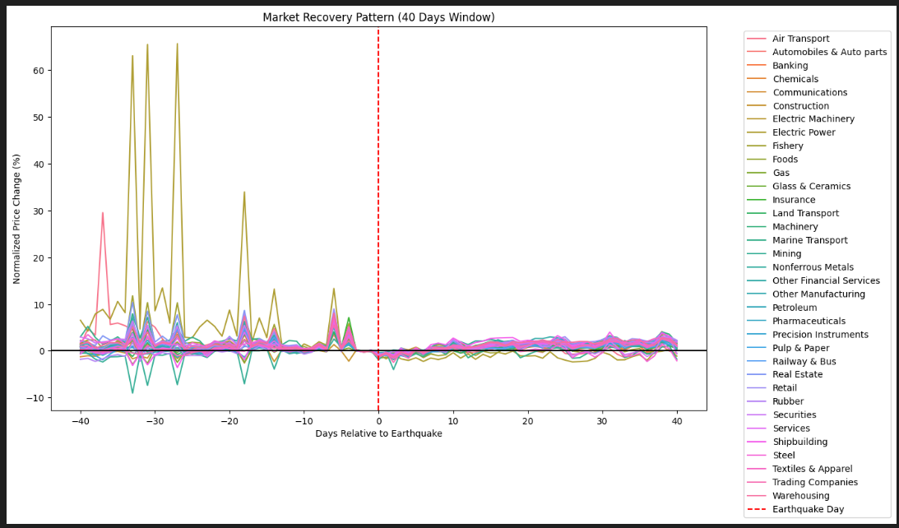

**Metric Definitions**

* **max_impact**: The largest percentage drop in stock prices immediately after an earthquake.
* **days_to_recover**: Time (in days) for stock prices to return to pre-earthquake levels.
* **volatility**: Magnitude of price fluctuations during the recovery period (higher = more instability).

**Key Observations**

1. **All industries experienced negative stock price impacts** (all max_impact values are negative), suggesting earthquakes generally correlate with short-term market declines.
2. **Recovery times vary widely**: Some industries rebounded in 2–5 days (e.g., Glass & Ceramics, Securities), while others took weeks (e.g., Electric Power: 39 days).
3. **Volatility is highest in industries with prolonged recovery** (e.g., Electric Power: 14.6 volatility), indicating prolonged uncertainty.

**Industry-Specific Insights**

**1. Most Impacted Industries**

* **Mining**:
  + **Max Impact**: -4% (highest decline).
  + **Recovery**: 5 days (relatively fast).
  + **Volatility**: 8.19 (moderate).
  + **Why?** Mining is directly affected by earthquakes (disrupted operations, damaged infrastructure). Fast recovery suggests investors expect short-term disruptions but no long-term damage.
* **Electric Power**:
  + **Max Impact**: -2.37%.
  + **Recovery**: 39 days (slowest).
  + **Volatility**: 14.6 (highest).
  + **Why?** Power infrastructure damage causes prolonged outages and uncertainty. High volatility reflects ongoing risks (e.g., repair delays, regulatory scrutiny).
* **Trading Companies, Steel, Petroleum**:
  + **Fast recovery (3–5 days)** despite moderate declines.
  + **Why?** These industries may have supply chain redundancies or benefit from post-disaster demand (e.g., steel for reconstruction).

**2. Least Impacted Industries**

* **Other Financial Services, Gas, Real Estate**:
  + **Smallest declines** (e.g., Gas: -0.71%).
  + **Fast recovery (2–5 days)**.
  + **Why?** Less physical exposure to earthquakes. Financial services may hedge risks, while utilities like gas are seen as stable.

**3. Unexpected Patterns**

* **Construction**:
  + **Small decline (-0.87%)** despite potential post-disaster demand.
  + **Why?** Investors might anticipate long bureaucratic delays before reconstruction begins.
* **Pharmaceuticals**:
  + **Low volatility (6.01)** despite 8-day recovery.
  + **Why?** Consistent demand for medical supplies post-disaster reduces uncertainty.

**Key Trends**

1. **Direct vs. Indirect Exposure**:
   * **High Impact**: Industries with physical assets (mining, power, marine transport) suffer most.
   * **Low Impact**: Service-oriented sectors (financials, retail) are less affected.
2. **Recovery Time vs. Volatility**:
   * Longer recovery periods correlate with higher volatility (e.g., Electric Power: 39 days, 14.6 volatility).
   * Short recovery = lower uncertainty (e.g., Glass & Ceramics: 3 days, 8.42 volatility).

**Suggestion**

* **Investors**: Avoid industries with high max_impact and slow recovery (e.g., Electric Power) during seismic activity. Consider short-term volatility in mining.
* **Companies**: High-impact industries (mining, power) should prioritize disaster resilience and investor communication.

1. **Europe (N100):** see result in

* Techlabs_WS_Team3\02_code\1_analysis\N100_and_major_earthquake.ipynb

**3.** **China (000001.SS)**: see result in

* Techlabs_WS_Team3\02_code\1_analysis\china_and_major_earthquake.ipynb

**4. India (BSEN and NSEI)**: see result in:

* Techlabs_WS_Team3\02_code\1_analysis\BSESN_and_major_earthquake.ipynb
* Techlabs_WS_Team3\02_code\1_analysis\NSEI_and_major_earthquake.ipynb